|  |  |  |
| --- | --- | --- |
|  | **G H Raisoni College of Engineering and Management**  **Wagholi, Pune**  **Department of Artificial Intelligence**  (An Autonomous Institute Affiliated to SPPU, Pune) | **C:\Users\LENOVO\Desktop\Logo1.jpg** |

**MINOR PROJECT ON**

**“ Hotel Management System “**

**Submitted By**

**Name of Student : Devashri Nandkumar Bhosale**

**Roll No : A19**

**T.Y.BTech(AI)**

**UNDER THE GUIDANCE OF**

**Prof. VAISHALI BAVISKAR**

**Department of Artificial Intelligence**



**G.H.Raisoni College of Engineering and Managment**

**Wagholi, Pune – 412207**

**2022-23**

1. **INTRODUCTION**

The hotel management system is one of the best sources for all stages of people as they provide detailed information about the rooms, food service, management, etc. The hotel management project is not an easy task because we develop more than 100 modules for implementation. This is the reason companies and colleges students are like to develop perfect results for their enhancement.

The  hotel management is not one concept, but many tied together under one umbrella.

Successful hotel management is about being able to adapt and meet challenges within a range of roles and responsibilities. Placing yourself on a scale of personal growth is especially important for a hotel manager.

There are always new strategies, traveller preferences, or industry technologies emerging to keep track of. Even within the hotel industry, new roles are always being created that will affect the way one manages their property; so it pays to have your finger on the pulse.

Hotel management is really about successfully overseeing every operation of the business to ensure consistent growth and development. This can involve the management of anything related to the hotel industry and requires knowledge of distribution strategy, finance and accounts, customer service, staff management, marketing, catering management, hotel administration and more.

This is a Project work undertaken in context of partial fulfillment of Minor Project.I have tried my best to make the complicated process of Hotel Management System as simple as possible using Structured & Modular technique & Menu oriented interface. I have tried to design the software in such a way that user may not have any difficulty in using this package & further expansion is possible without much effort. Even though I cannot claim that this work to be entirely exhaustive, the main purpose of my exercise is perform each Employee’s activity in computerized way rather than manually which is time consuming. I am confident that this software package can be readily used by non-programming personal avoiding human handled chance of error. This project is used by one type of users

1. Administrator (management of the Hotel).

Administrator can maintain daily updates in the hotel records. Administrator is must be an authorized user. He can further change the password. There is the facility for password recovery, logout etc. The main aim of the entire activity is to automate the process of day to day activities of Hotel like Room activities, Admission of a New Customer, Assign a room according to customer’s demand, checkout of a computer and releasing the room and finally compute the bill etc. The limited time and resources have restricted us to incorporate, in this project, only a main activities that are performed in a HOTEL Management System, but utmost care has been taken to make the system efficient and user friendly. “HOTEL Management System” has been designed to computerized the following functions that are performed by the system: Room Detail Functions Opening a New Room Modification to room assigned Check-in and check-out Detail Functions Admission of New customer Check-out of customer Room assigning related to customer’s need.

Individual customer Report

here are ten advantages of implementing a modern hotel management system.

### 1. Save time on admin tasks

The right hotel management software will vastly cut down the time you spend on manual administrative tasks. The software does the majority of the work and lets you divert your time to more important tasks, such as serving your guests.

More than any other software you use, a hotel management system will touch every department at your property. Front of house, revenue management, housekeeping… If you pick the right solution, you can make significant time savings across almost every area of your business, also boosting your staff’s productivity and satisfaction.

### 2. Develop strong relationships with your guests

A more streamlined check-in and check-out experience will boost your guest happiness. And that’s only the tip of the iceberg – anything from improved communication and additional services will also heighten guest loyalty. using the best property management software will likely mean an increased level of retention in both guests and staff.

### 3. Implement an effective revenue management system

Most hotel management systems include pricing tools and other features to optimize revenue.

Gone are the days of having just a peak season price and a low season price – if you’re not setting prices in a more sophisticated manner, you’re losing out on bookings and not making the most of the guests that do book. You should be able to create and customize product rates, rate dependencies, and special offers and rules such as package rates.

### 4. Increase bookings

Every feature in your hotel management system should work to improve your overall number of bookings. Whether you intend to explore new markets or boost bookings in low season, the right software system is all about optimizing and maximizing what you can achieve.

Revenue management and a direct booking engine are two obvious features that will help you in this regard, but everything from integrations to smart reporting and automation will ultimately contribute.

### 5. Accurate daily reports

Hotel management, finance and revenue teams will have access to accurate daily earnings reports thanks to data-savvy hotel management software.

Meanwhile, operations and marketing reports will help you and your team to make reliable, data-driven decisions across your business.

### 6. Prevent double bookings and manual errors

Hospitality management software systems are programmed to avoid double bookings and [overbookings](https://www.mews.com/en/blog/hotel-overbooking-strategy). Thanks to task automation, they also help prevent errors when front desk staff are inputting important customer data like name, passport details, and card numbers.

This means a better guest experience (no awkward follow up conversations asking for their correct details), more time for staff to focus on their important work, and more reliable business data and reporting.

### 7. Analyze your customer base

Market and guest segmentation is another important benefit of the right guest management software system. The GM and Marketing Managers can keep track of the different types of visitors, with key demographic breakdowns such as age, gender and nationality.

This data allows you to make informed decisions on your marketing strategy. and increase the long-term revenue trends of your business.

### 8. Transform your property

The many benefits of a hotel management system could help you grow your business in a short amount of time. If you’re not currently using the right solution, migrating to a more modern software could help you see big improvement almost immediately.

Need of the study

Today, even the smallest run hotels have a hotel management system in place to meet each task of managing their hotel. In order to complete on a large scale. A hotel need an efficient system to be effective. Management system, once exclusive to large scale chains, have been adapted to accommodate the needs of smaller hotels. Nut with so many options available, you need to consider these three basic aspects when deciding to implement or change systems.

1. Simplicity: the system with all the bells and whistles available might seem like the number one choice. However, remember the system should be simple enough to understand that anyone can use it efficiently. The design should be attractive and user friendly. your staff should be able to understand how to use the program smoothly.

2. Flexibility: not every hotel is a like there are different room types, cleaning services guest types, etc. The system must be able to adapt to the characteristics and peculiarities of each hotel.

3. Accessibility: small and independent business owners might need to access hotel information at any time. Whether the your in office or on the road, you should able to access all activity within your hotel.

Objective of study

The aim of the proposed system is to provide solutions to the problems stated above and help the user to manage the hotel effectively and efficiently through:

Adequate Record Keeping :To eliminate manual record keeping and install an electronic record keeping thereby ensuring adequate record of transactions are kept. This ensures a centralized system where all necessary data and information can easily be accessed, Tracked, and monitored

Reduced Incidence of Fraud : The program is envisaged to reduce the incidence of fraud both by staff and outsiders through proper record keeping, tracking and monitoring of transaction operations in the organization.

Maximum Accountability: To Instill accountability in the process of management in the hotel organization by not only reducing incidence of fraud, but also eliminate wastages. Provide Data Security: The study will install security measures by providing different access levels to various staff.

Effective Resource Management: The Human Resource module (HR) and Finance & Account (F&A) module will enable effective utilization of financial and human resources by comparing the accounts receivable with the account payable and complete record of personnel through the nominal roll module will enhance staff deployment and productivity.

Increased Profit Line for The Organization: when there is reduced incidence of fraud this and proper management of resources this will enable increased profit line for the organization

Reduced Time Consumption: A good search algorithm will be implemented on the web application to enhance the search facility whereby users of the system can search for all kinds of data using various criteria. The system can be handy to the user in the following ways:

¬ To automatize the work such as gathering information, gathering Hotel Staff information, Workers’ roster, food ordering and Hotel administration in general.

¬ To atomize different types of reports.

¬ Removal of Data Redundancy.

¬ To create a centralized system where all necessary data and information can be accessed easily

SCOPE OF STUDY

The study is focused on the critical operations carried out within the hotel administrative system. These major operations include

• Front-desk operations (customer management, room allocation, cashier posting)

• Accommodation (Hotel room management, staff schedules, inventory).

• Assets management (Fixed, Floating asset).

• Staff record Management.

• Restaurant & Bar operation.

• Staff payroll (Pay slip).

• Accounts Receivable &Payable.

The goals are achieved based on ability of the computer to store large amounts of data which is very useful to store information regarding the transactions of Sacoba Hotel. The study is limited to the following: RECEPTION MODULE: The Reception module covers all the customer allocation and booking with the sub-fields (Customer Details, Room Allocation, and Cashier Posting).

ACCOMODATION MODULE: The Accommodation covers all Room Maintenance, Housekeeping Schedules and room inventory.

FINANCE & ACCOUNT: Covers the staff payroll, assets register, accounts receivable and accounts payable. CATERING MODULE: Covers the food ordering maintenance and bar transactions.

ADMINISTRATION & GENERAL SERVICES: Covers Personnel staff record keeping and the stores with inventory.

**2.LITERATURE SURVEY**

In the literature review we consider and examine the work done by other scholars and researchers who have broached on this particular topic (Hotel Management System) Technology has made a considerable impact on the Hospitality industry in recent years and will continue to do so with the increasing use of computer, controlled equipment and the growth of information technology in general” (Jones and Lockwood, 1989, p.6) Really in the last two decades, technology has become far more advanced and far more widely used throughout all types of industry. The tourism and hospitality industry is no exception. Indeed, many tourism and leisure establishments rely on technological systems for the vast majority of their operations. They use a range of computer programs from everything to bookings, communications, security and payments. If a hospitality establishment does not use some sort of advanced technological system in its operations, it is deemed to be out of date and disorganized. Indeed, James Bardi begins to outline the importance of these programs by claiming that “a well-organized reservation system allows hotels to ensure a steady flow of guests into their properties”. Furthermore, “Profitable business ventures rely on effective marketing, which includes reviewing people who require hotel products and services, determining their specific needs, developing products and services that meet those needs, and making a profit on the sale of those products and services” (Bardi, 2010). Part of the reason why hotels utilize technological systems in their operations is because it keeps them up to date in terms of where they are placed in the market. It makes work easier for staff members, allowing them to work more efficiently and taking away time consuming activities which can be carried out by the technology. In some hotels, the utilization of technological systems mean that fewer staff members are needed and this saves considerable costs. For others, especially luxury hotels, this is not the case but it means that the staff can be free to attend to customers on a more personal basis, thus upholding high standards. Therefore, it is understandable that 5 star hotels must ensure that they employ the most advanced technology available. This is because their priority is maintaining their position and status as a luxury brand, rather than cutting costs, which would be more of a priority for budget hotels which cater to a lower end market. Therefore luxury tourist establishments rely on top quality technological systems. It is clear that technology used in hospitality establishments it is also used to make customers’ lives more convenient. Peacock notes “automated hospitality enterprises will become an increasing feature of the industry, particularly at the budget end of the market, but the main use of information technology will be in enhancing customer service, rather than replacing it”. For example, many hotels use technological booking systems which make it easy for clients to book online and to have all the information they need about the rooms available to them. They also use technology within the hotel to benefit the customer during their stay. For example, many have advanced communications systems installed in the rooms which means that those on business trips can continues with their work while they are guests at the hotel. Once again, in 5 star hotels, it is all the more important to provide these facilities; customers pay a lot of money and so expect to have a certain amount of facilities and quality additions provided for them (Peac

1. **EXISTING SYSTEM**

This Project is coupled with material on how to use the various tool, sub sets available in Python AND MY SQL.

The need of today’s software development is competence in a GUI based front-end tool, which can connect to Relational Database engines.

This gives the programmer the opportunity to develop client server based commercial applications.

These applications give users the power and ease of a GUI with the multi user capabilities of Novell, UNIX or WinNT based RDBMS engines such as MY SQL .

1. **PROPOSED SYSTEM**

we are taking a look at the management system, the processes, methodology and the steps taken to create the system, we will evaluate the research methodology and elaborate on the basic functionalities of our management system. This approach will be used in order to overcome the challenges highlighted in the previous chapter.

The system is created as an interactive web-based application to replace the current manual system of transaction. This Automated system requires full control on all hotel operations or activities. It is essential due to the fact that the electronic means is more efficient in utility than the manual system.

The Project work will ensure reservation of hotel rooms, staff management, and resource management. A “Use Case” scenario is the room search for room reservation. Users may face difficulties searching between available and booked rooms, but the automated system would search more efficiently with the proficient search algorithm. All details of the rooms are stored in the database servers and can be retrieved or modified with very little stress. Another “Use Case” is the accounts receivable and payable field of the F&A module. The accounts receivable simply captures all funds coming-in with their sources and dates while the accounts payable displays the money going-out of the organization with their destination. The business flow is quite simple; however, to accomplish all these tasks is burdensome for both the customer side and the hotel side without an efficient and integrated hotel management system.

With the HMIS (Hotel Management Information System), Restrictions and access levels can be stipulated to prevent unauthorized or unwanted personnel from any point of operation i.e. workers cannot have access to areas not pertaining to their roles as set by the administrator. The administrator can also decide what operations can be carried out where on the application. For example a staff with the role “Housekeeping” should not be able to modify the schedule set for him/her for the month by the House keeping Manager, and the catering staff should not have access to the “cashier posting” of customer accommodation.

Staff Payroll can be generated and added to records with details from the staff record (HR) and accounting computation.ie specific details from the staff record will be brought up during the preparation of staff salaries and the gross and net pay will be calculated. The Assets Register will enable record keeping of both the fixed asset and floating asset in the organization.

The project simply serves as an ERP (Enterprise resource planner/ Management System) for the hotel organization and should function effectively if utilized properly.

In Order for the goals of the automated system to be achieved the design of the HMIS takes the following into consideration:

• The system must make the hotel services fully known to the customer such as the room details and pricing. • The system must be able to search databases or records to provide quick result based on users query.

• The system should ensure data consistency and no duplication of data no matter how small.

• The system must be accessed only by authorized persons and should indicate the user at any point in time (User Authentication).

1. **PROBLEM STATEMENT & ARCHITECTURE**

The old manual system was suffering from a series of drawback. Since whole of the system was to be maintained with hands the process of keeping, maintaining and retrieving the information was very tedioys and lengthy. The records were never used to be a systematic order there used to be lots of difficulties in associating any particular transaction with a particular context. If any information was to be found it was required to go through the different registers, documents there would never exit anything like report generation. There would always be unnecessary consumption of time while entering records and retrieving records. Once the records were entered it was very difficult to update these records.

FOLLOWING POINTS SHOULD BE CONSIDERED :

- Details of the information needed for each document and report.

- The required frequency and distribution for each document.

- Probable sources of information for each document and report.

ARCHITECTURE

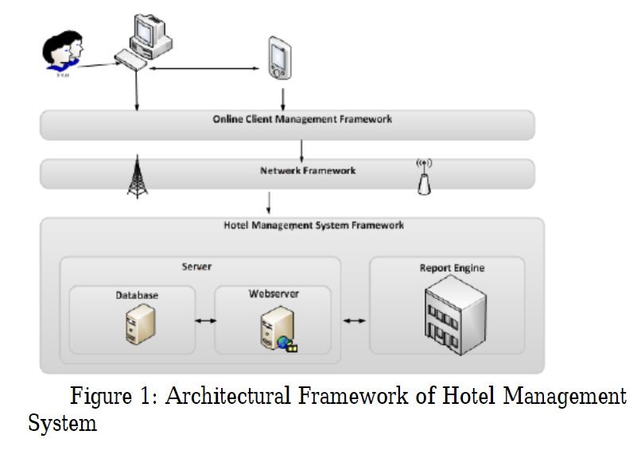

An architectural framework for an Hotel management system is developed and presented in Figure 1.

The framework highlights the structure of the developed system together with the way they interactions with each other.

1. **WORK FLOW**

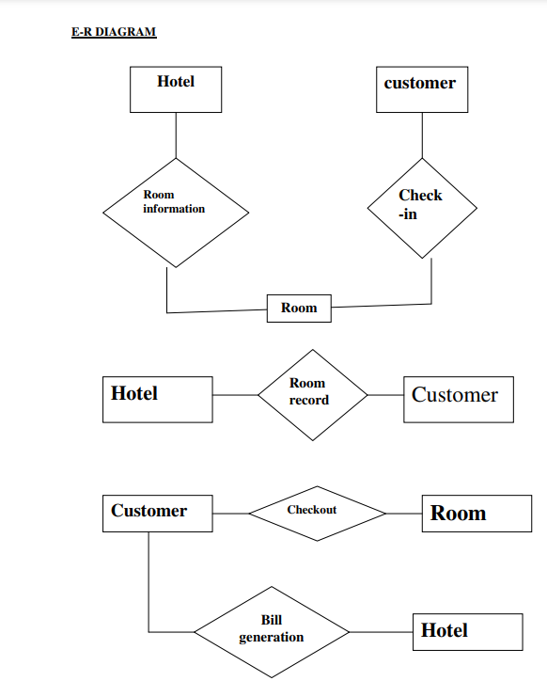

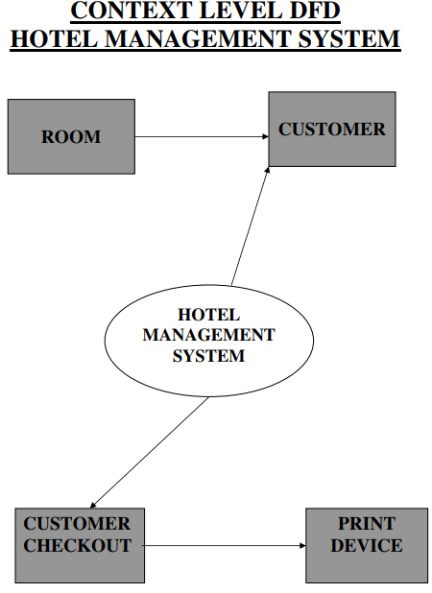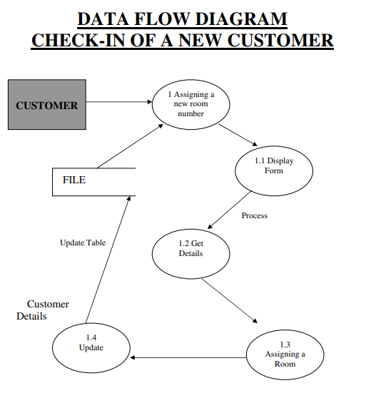

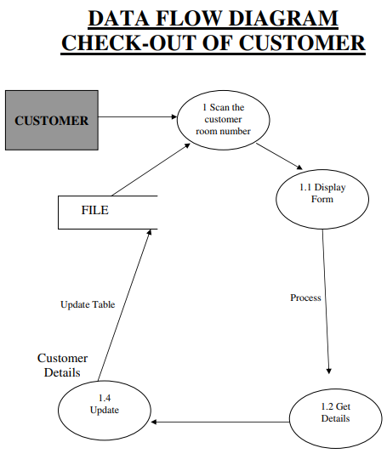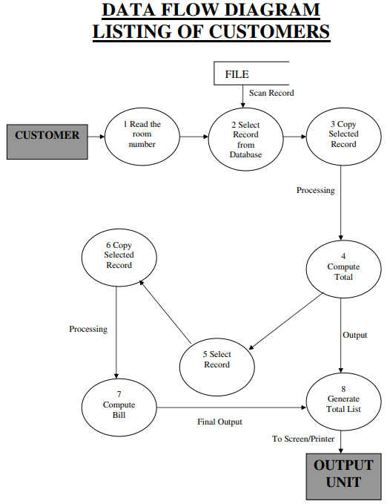

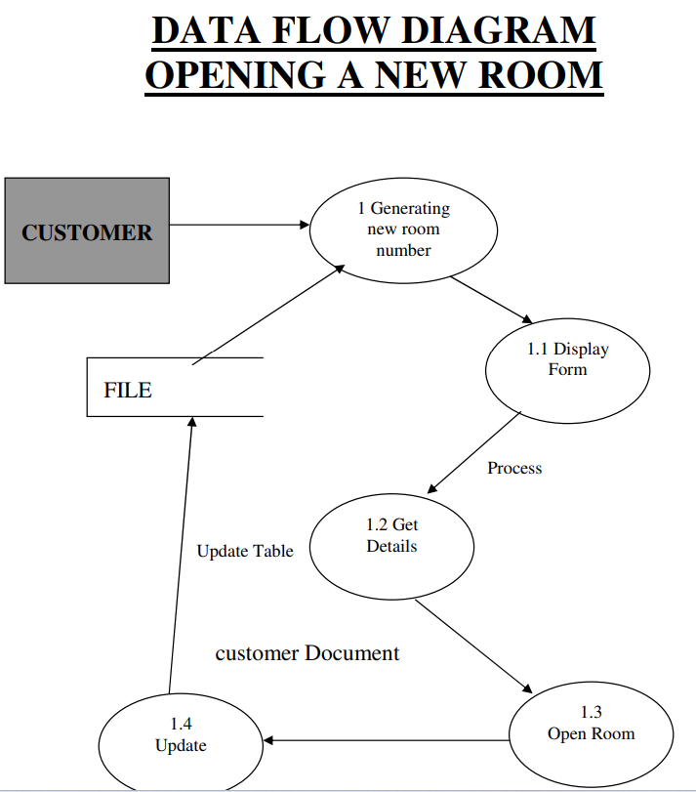

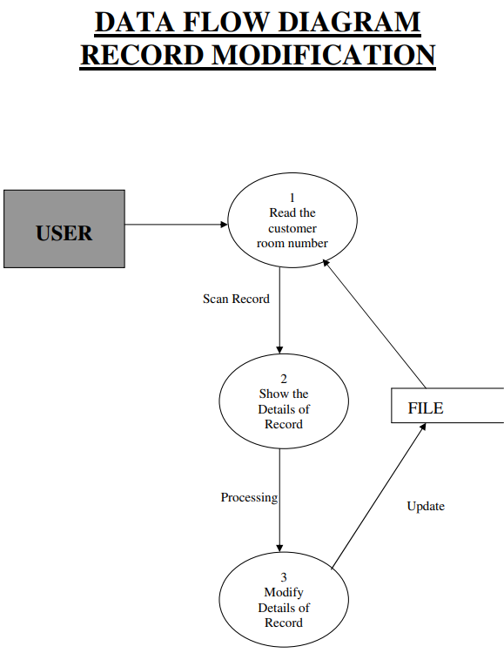

1. **ALGORITHM:**

1. Login To the System and Confirm the Admin access.

2. Add Customer Details to the customer Tab.

3. The Details of available rooms added by the hotel staff in the Details tab.

4. the available room will book by the customer as per choice through the room tab.

5. Billing details are also included in the Room tab.

6. To LOGOUT the system simply click on the logout Button.

1. **FLOWCHART**

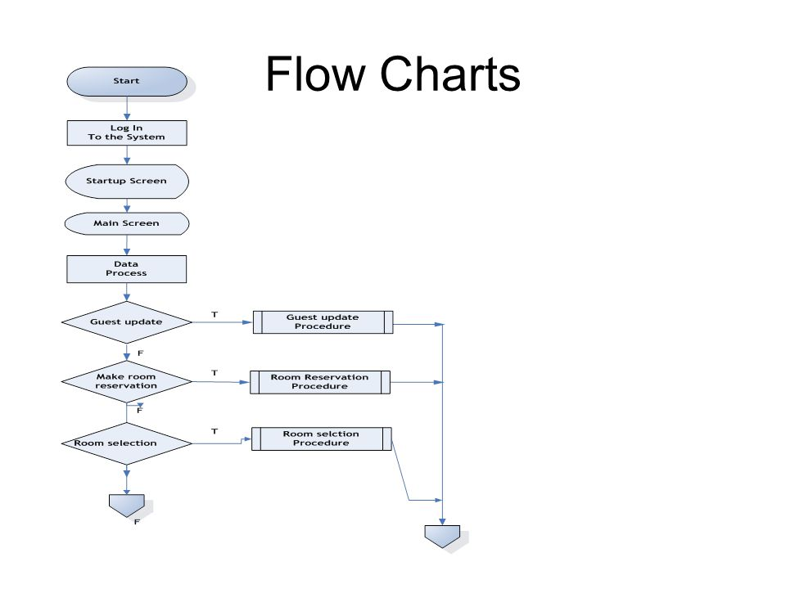

1. **RESULTS**

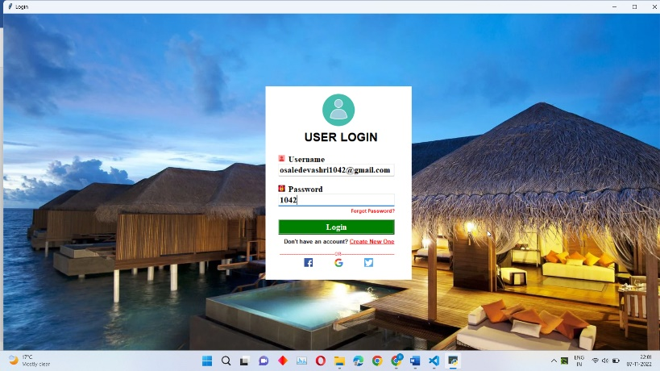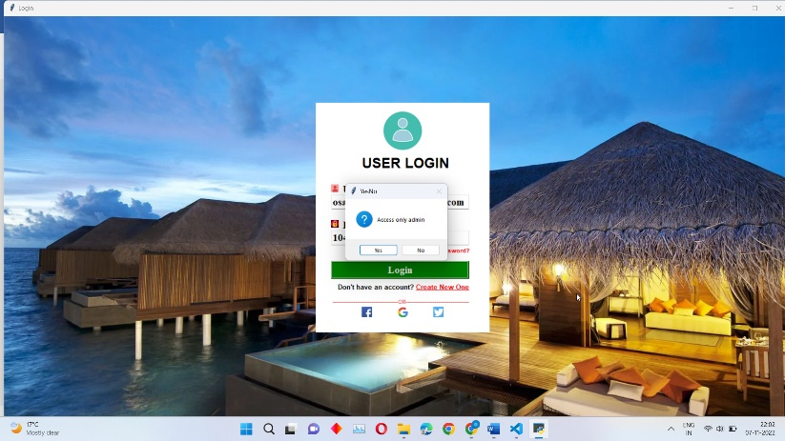Screenshot Of Hotel management system interface

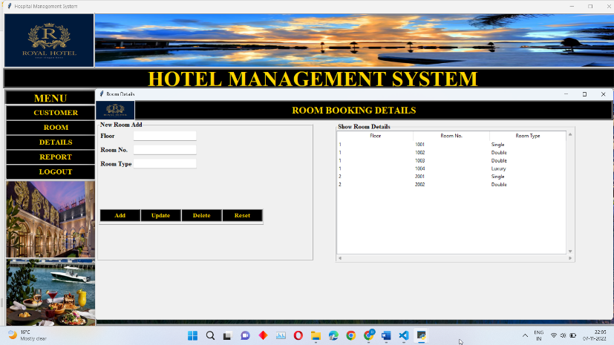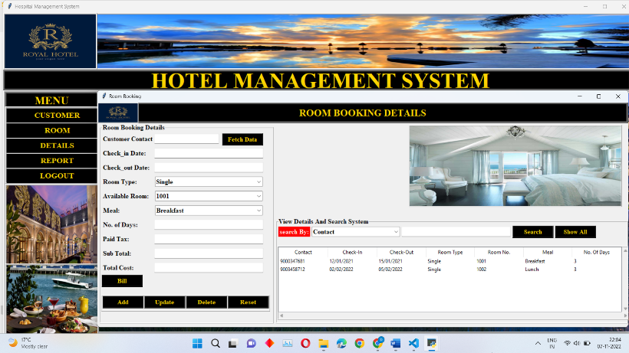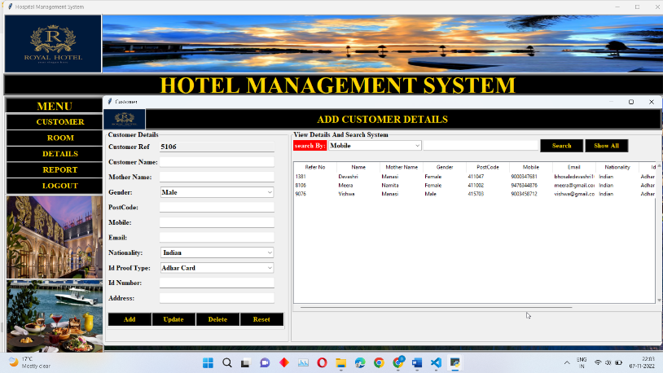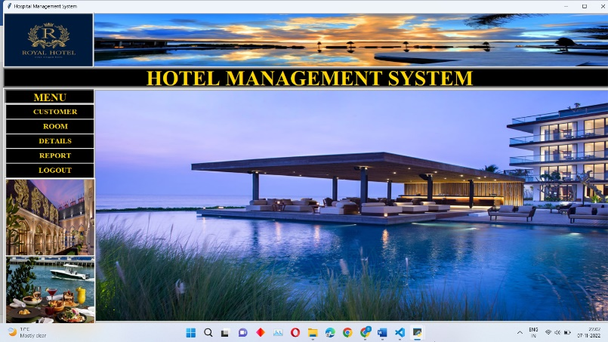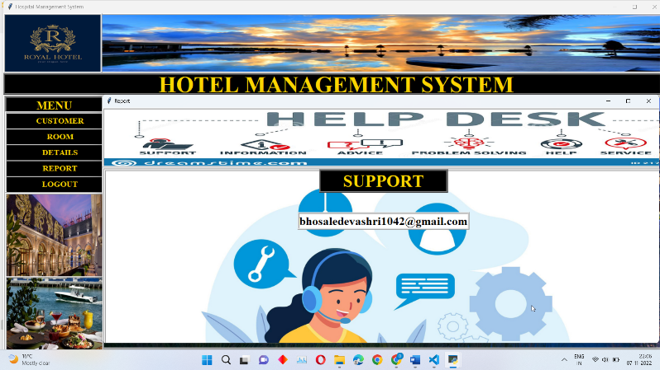

1. **ADVANTAGES**

Performance: The manual handling of the hotel record is time consuming and highly prone to error. This work will improve the performance of the Hotel management system, due to fast retrieval of data and coordination of data in a centralized manner.

¬ Efficiency: The project work enhances efficiency in the activities of the Hotel since there is division of labour through the privilege granted other users.

¬ Control: The complete control of the electronic system is under the hands of authorized person who has the password to access this project and illegal access is not supposed to deal with. All the control is under the administrator and the other members have the rights to just see the records not to change any transaction entry.

¬ Security: Security is the main criteria for electronic hotel management system. Since illegal access may corrupt the database and ensure protection of stored data. Therefore this project work ensures security of data.

1. **CONCLUSION AND FUTURE WORK**

In conclusion we believe this project if properly utilized will save time, reduce the amount of work the administration has to do, and will replace the stationery material with electronic apparatus. The system should also serve as a major tool to improving the efficiency in Hotel management. Hence a system with expected results has been developed but there is still room for improvement.

In terms of experience gained through the duration of this project study, the students have been able to have broader knowledge about the management of Hotel organization using manual and automated procedures. The students have also been able to improve their knowledge in developing enterprise applications.

Biometric measures such as fingerprint, retinal scan etc. should be included in the system to ensure good security of the system thereby avoiding impersonation and unauthorized access to stored data thereby preventing loss of vital information.

¬ Implementation of a multi modal hotel management control system in delivery of service to customers.

¬ Implementation of more modern online facilities that might help prospective customers interact (limitedly) more with the system and the Hotel in general such as PayPal for making online transactions.

¬ Adequate provision should be made for customers to interact with authorized users of the hotel for reservation using their mobile phones.

1. **REFERENCES**

* S. Koolmanojwong, "Analysis and Design of B to C E-Marketplace for Tourism with UML " M.S. Thesis, Faculty of Science and Technology, Assumption
* University, Bangkok, Thailand 2000.
* M. J. O'Fallon and D.G. Rutherford.(2011).Hotel Management and Operations | CA College of Ayurveda.
* Available: http://www.ayurvedacollege.com/ amazon_store
* /item / 0470177144
* S. Koolmanojwong and P. Santiprabhob, "Intelligent Electronic Marketplace for Tourism."
* E. W. T. Ngai and F. K. T. Wat, "Design and development of a fuzzy expert system for hotel selection," Omega, vol. 31, pp. 275-286, 2003.
* G. Jingzhi, et al., "Alibaba International: Building a Global Electronic Marketplace," in e-Business Engineering, 2006. ICEBE '06. IEEE International Conference on, 2006, pp. 545-548.
* W. S. Gray and S. C. Liguori, Hotel and Motel Management and Operations, Fourth Edition ed.: Prentice
* Hall, 2002.
* W. J. Relihan Iii, "The yield-management approach to hotel-room pricing," The Cornell Hotel and Restaurant Administration Quarterly, vol. 30, pp. 40-45, 1989.
* M. S. Islam, et al., "An Automated Intelligent Hotel Management System," in 2009 Interdisciplinary Conference in Chemical, Mechanical and Materials
* Engineering (2009 ICCMME), Melbourne, Australia,
* 2009.
* Ogirima Sanni Omuya “Computerized Hotel Management”.Unpublished Higher National Diploma (HND) dissertation,Department of Compter Science, Kwara State Polytechnic,Ilorin, Nigeria.
* Landvogt, M. (2004) Online booking engines for small and medium-sizedenterprises as a tool for improved distribution and yield management in New Zealand’s tourism industry. In Smith, K. A. and Schott, C. (2004) eds. Proceedings of New Zealand Tourism and Hospitality Research Conference 2004. Wellington, 8-10 December. pp. 191-198. Available online at:33 http://www.vms.vuw.ac.nz /vuw/fca /vms/files/aa42.pdf (Accessed 21st July 2006).
* Law, R., J. Wong (2003) Successful factors for a travel web site: Perceptions of online purchasers in Hong Kong. Journal of Hospitality and Tourism Research 27(1), pp. 118-124.
* Law, R., K. Leung (2005) Online airfare reservation services: A study of Asian-based and North American-based travel websites. Information Technology
* and Tourism 5(1), pp. 25-33
* Schegg, R., T. Steiner, S. Frey, J. Murphy (2002) Benchmarks of website design and marketing by Swiss hotels. Information Technology and Tourism 5(2), pp. 73-89
* Ivanov, S (2002) Online hotel reservation systems. Proceedings of “Tourismin 21st Century” Conference, Sofia University, 29th November 2002, Sofia, Bulgaria, pp.
* 248-254(inBulgarian).

**CERTIFICATE**



This is to certify that the minor project report entitles

# “HOTEL MANAGEMENT SYSTEM”

|  |  |
| --- | --- |
| **Submitted By** | |
| **Devashri Bhosale** | **A19** |

are the bonafide students of this institute and the work have been carried out by them under the supervision of **Prof. Vaishali Baviskar** & it is approved for the partial fulfillment of the requirement.

Prof. Vaishali Baviskar Prof. Rachna Sable

Guide Head of Department

Dr. R. D. Kharadkar

Campus Director

GHRCEM, Pune